# Task 1

<https://opensource-demo.orangehrmlive.com/web/index.php/auth/login>

Try to use contains , xpath axes, text functions

Write a minimum 3 XPath and 3 CSS Selector for the username

Ans: CSS Selector: input[name=’username’]

input[placeholder=’Username’]

input.oxd-input[placeholder=’Username’]

XPath: //input[@name='username']

//input[contains(@placeholder,'Username')]

//input[contains(@class, 'oxd-input')]

Write a minimum 3 XPath and 3 CSS Selector for the password

Ans: CSS Selector: input.oxd-input[placeholder=’Password’]

input[type=’password’]

input[name=’password’]

XPath: //input[contains(@name, 'password')]

//input[@class='oxd-input oxd-input--active' and @name='password']

//input[@type='password']

Write a minimum 3 XPath and 3 CSS Selector for the login button

Ans: CSS Selector: button[type=’submit’]

button.oxd-button

button.oxd-button[type=submit]

XPath: //button[contains(@type,'submit' )]

//button[@type='submit' ]

//button[@type='submit' and @class='oxd-button oxd-button--medium oxd-button--main orangehrm-login-button']

//button[@class='oxd-button oxd-button--medium oxd-button--main orangehrm-login-button']

# Task 2

<https://opensource-demo.orangehrmlive.com/web/index.php/auth/login>

admin/admin123

Write dynamic xpath which should match all below elements

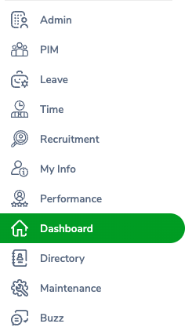

Click on Admin Tab

Click on Add button

Type A in employee name and write XPath which matches all element in suggestions

Ans: **package** SeleniumWebdriver;

**import** org.openqa.selenium.By;

**import** org.openqa.selenium.WebDriver;

**import** org.openqa.selenium.chrome.ChromeDriver;

**public** **class** Xpath {

**public** **static** **void** main(String[] args) **throws** InterruptedException {

WebDriver driver = **new** ChromeDriver();

driver.manage().window().maximize();

driver.get("https://opensource-demo.orangehrmlive.com/web/index.php/auth/login");

Thread.*sleep*(5000);

driver.findElement(By.*xpath*("//input[@name='username']")).sendKeys("Admin");

driver.findElement(By.*xpath*("//input[@name='password']")).sendKeys("admin123");

driver.findElement(By.*xpath*("//button[@type='submit']")).click();

Thread.*sleep*(3000);

driver.findElement(By.*xpath*("//a[@class='oxd-main-menu-item']")).click();

driver.findElement(By.*xpath*("//button[@class='oxd-button oxd-button--medium oxd-button--secondary']")).click();

driver.findElement(By.*xpath*("//input[@placeholder='Type for hints...']")).sendKeys("a");

driver.findElement(By.*xpath*("//div[@class='oxd-autocomplete-dropdown']"));

}

}

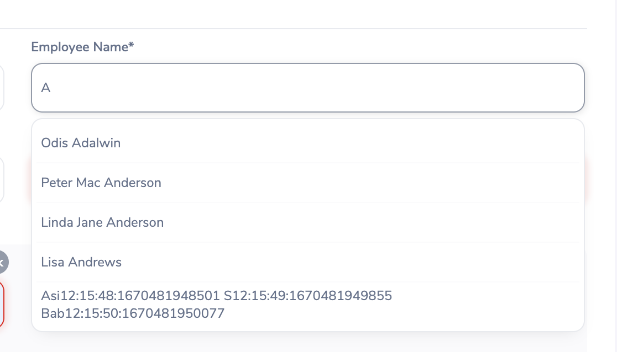

Write xpath (min 3 and max no limit) for all elements under Add User section

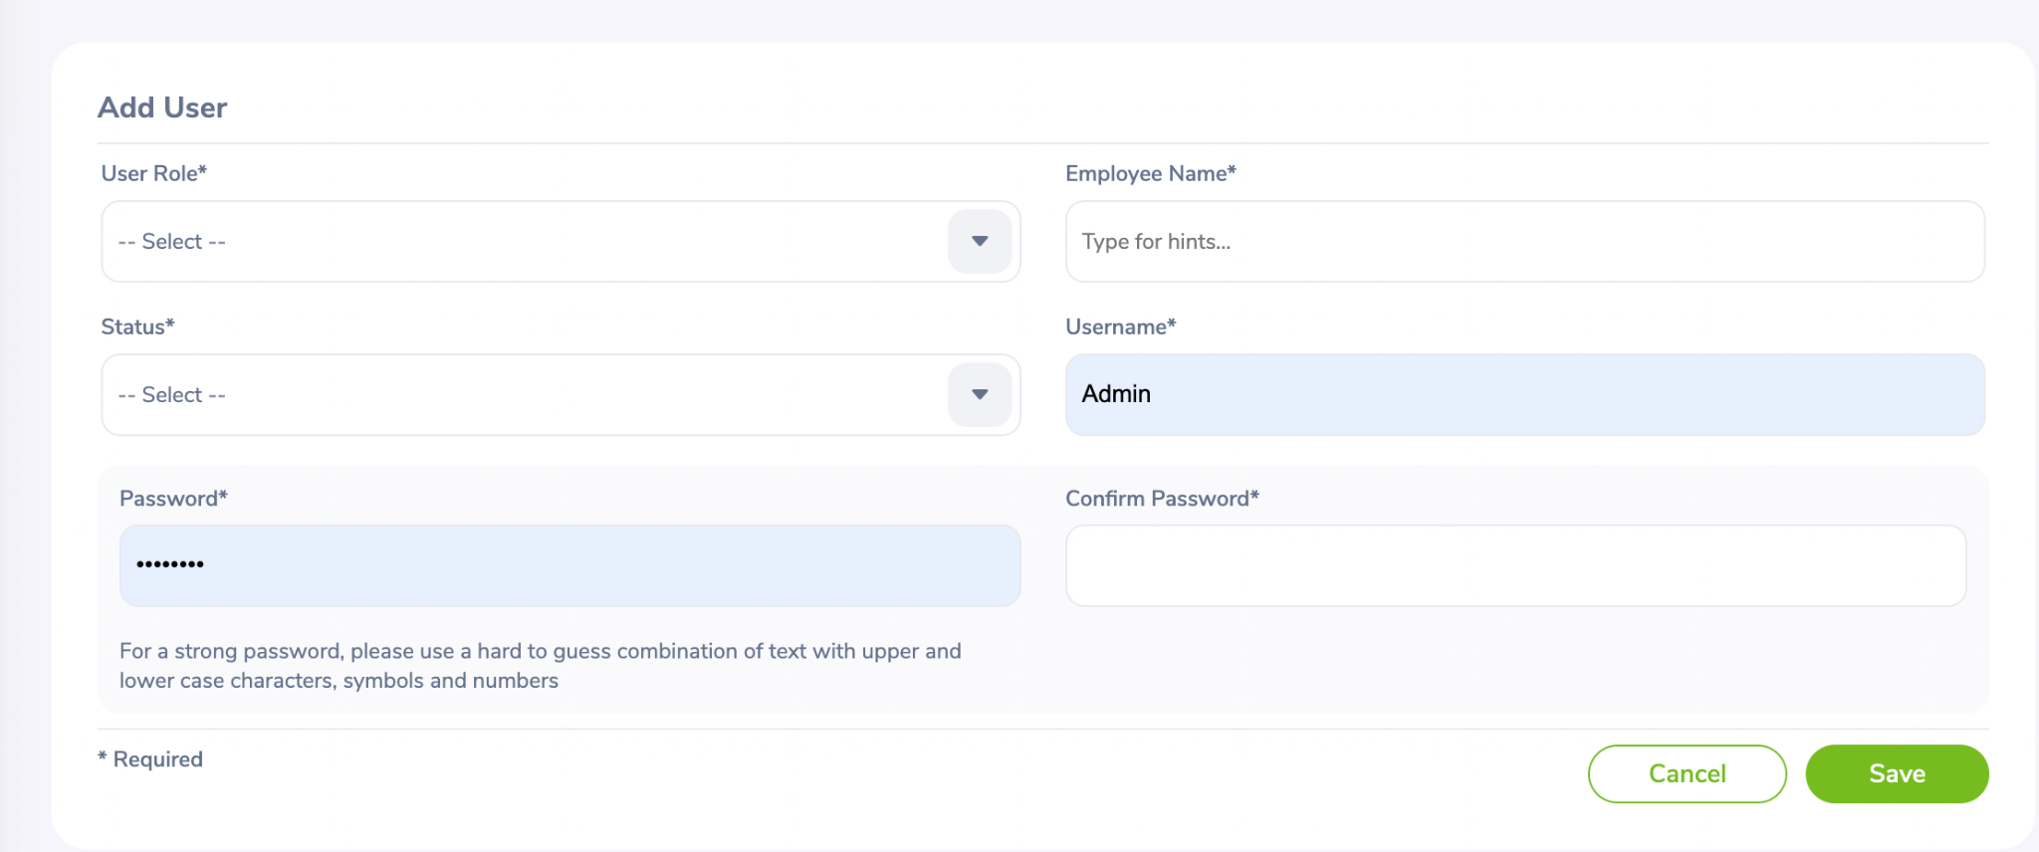

# Task 3

Write a script that should be able to add user > search user > delete the user.

Flow- Login > Admin> Add User> Search User > Delete User > Logout

Add an assertion after each section

<https://opensource-demo.orangehrmlive.com/web/index.php/auth/login>

Admin/admin123